Andy Ni

COMP 3710

Assignment 2

1. User runs the app and UI pops up

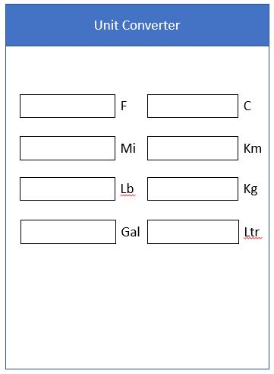

1. Enter in a number in Fahrenheit

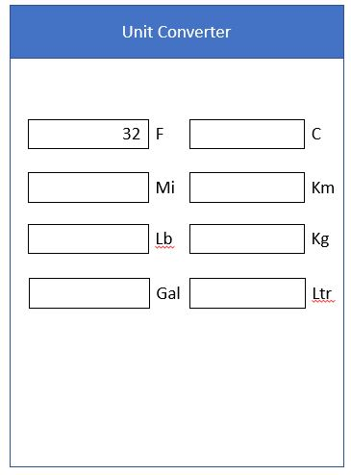

1. Automatically Convert

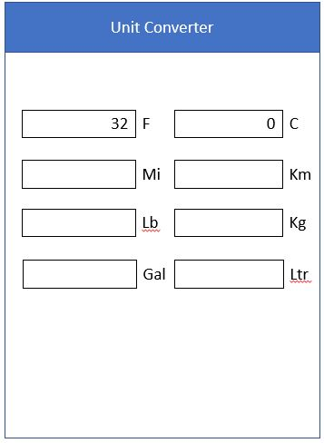

1. User runs the app and UI pops up



1. Enter in a number in Miles

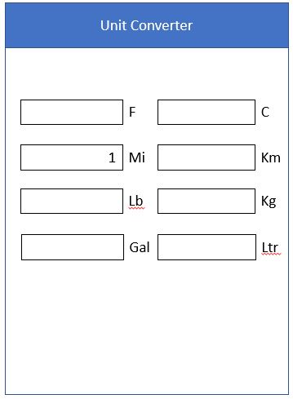

1. Automatically Convert

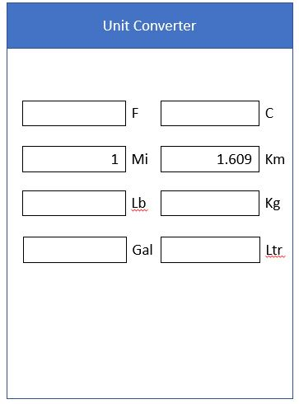

1. User runs the app and UI pops up



1. Enter in a number in Lbs

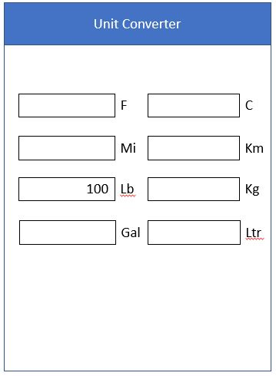

1. Automatically Convert

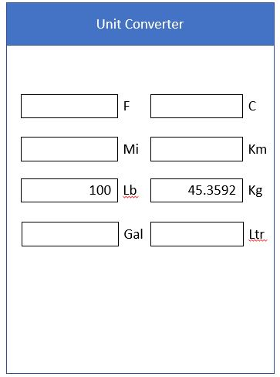

1. User runs the app and UI pops up



1. Enter in a number in Gallons

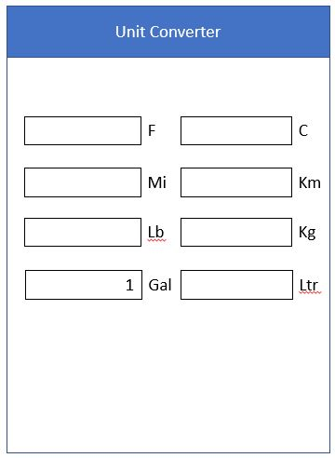

1. Automatically Convert

